Sixteenth ACM SIGPLAN
Erlang Workshop
http://erlang.org/workshop/2017/
Oxford, UK, September 8, 2017

Satellite event of
the 22nd ACM SIGPLAN
International Conference on Functional Programming (ICFP 2017),
September 3 - 9, 2017

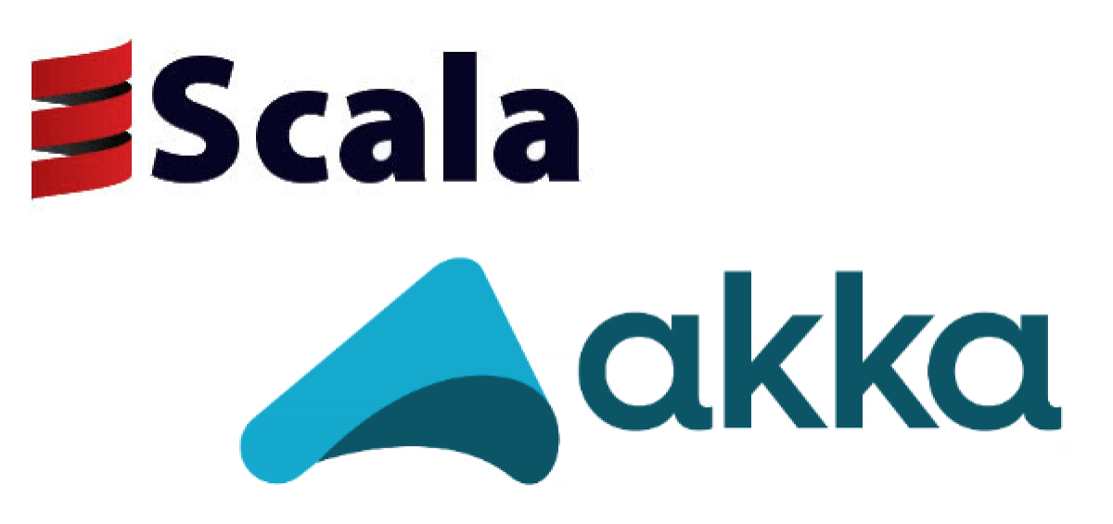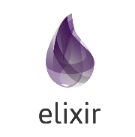

Workshop Objectives
The Erlang Workshop aims to bring together the open source, academic, and industrial communities of Erlang, to discuss technologies and lan guages related to Erlang. The Erlang model of concurrent programming has been widely emulated, for example by Akka in Scala, and even new programming languages were designed atop of the Erlang VM, such as Elixir. Therefore we would like to broaden the scope of the workshop to include systems like those mentioned above.
The workshop will enable participants to familiarize themselves with recent developments on new techniques and tools, novel applications, draw lessons from users' experiences and identify research problems and common areas relevant to the practice of Erlang, Erlang-like languages, functional programming, distribution, concurrency etc.
We invite three types of submissions.
- Technical papers (max. 12 pages) describing interesting contributions either in theoretical work or real world applications -- submission related to Erlang, Elixir, Akka, CloudHaskell, OCaml, and functional programming.
- Experience reports (max. 2 pages) describing uses of Erlang in the "real-world".
- Poster presentations (max. 2 pages) describing topics related to the workshop goals.

Important Dates
- Submission deadline: Fri May 26, 2017
- Author notification: Fri June 23, 2017
- Final submission for the publisher: Sat July 15, 2017
- Workshop date: Fri September 8, 2017
http://erlang.org/workshop/2017/

